## **Project Overview**

A Gen-AI powered application that automates job description extraction from company career pages, compares the required skills with a user's portfolio, and generates role-specific interview questions. Built using LangChain, LLaMA-3, Gradio, and ChromaDB.

## **Project Steps**

### **Step 1: Install Required Libraries**

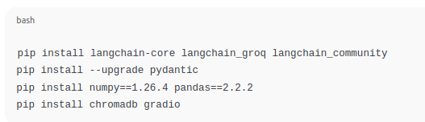

### **Step 2: Initialize the LLM (LLaMA-3.3-70B)**

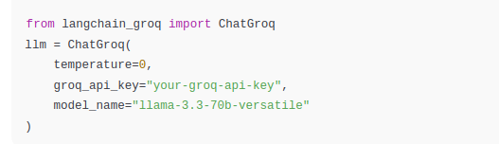

### **Step 3: Load Job Page and Extract Data**

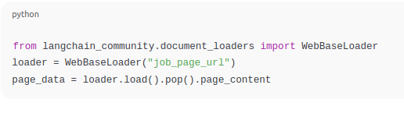

### **Step 4: Generate Structured Job Info (JSON)**

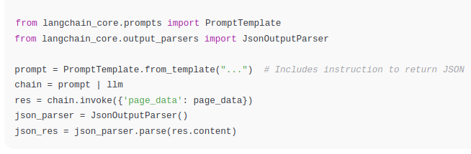

### **Step 5: Load User Portfolio**

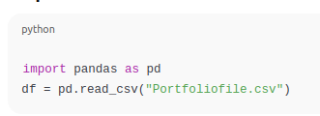

### **Step 6: Store Portfolio in ChromaDB**

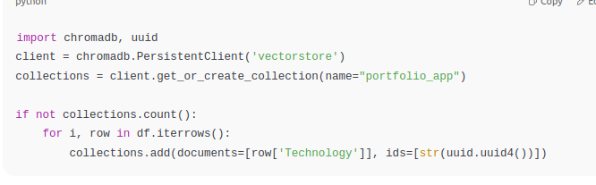

### **Step 7: Match Skills & Generate Interview Questions**

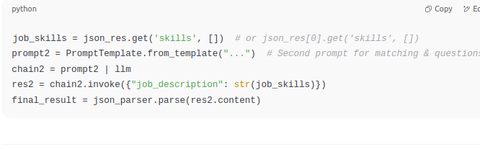

### **Step 8: Gradio Web App**

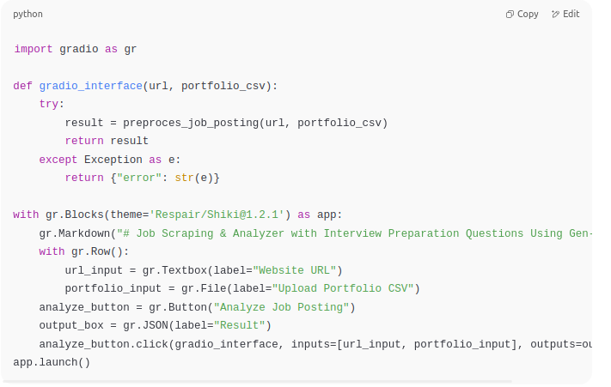

**Final Output :**

